**1: Character defining Johann Zahn (1min)**

Johann Zahn was a German scientist and theologian born in 1631. He is primarily remembered for his work in optics and for his contributions to the development of the camera obscura, an early precursor to modern cameras. Zahn's most notable work is "Oculus Artificialis Teledioptricus Sive Telescopium," published in 1685. In this book, he extensively described various optical instruments, including microscopes and telescopes, and provided detailed illustrations of them. Zahn's advancements in optics and his descriptions of the camera obscura laid the groundwork for the later development of photography. His work helped pave the way for the understanding of how light interacts with lenses and how images can be captured and projected through optical devices.

**Johann Zahn: [to himself] Today, I shall unlock the secrets of capturing light itself. With this creation, I shall transcend the boundaries of human perception.**

[He carefully adjusts a delicate lens, a hint of excitement dancing in his movements.]

**Johann Zahn: [with a sense of anticipation] This, my masterpiece—the world's first camera—shall forever change the way we see the world.**

[He holds up the camera, admiring its intricate design and the promise it holds.]

**Johann Zahn: [voice filled with conviction] Through this lens, I shall freeze moments in time, preserving the essence of life for all eternity.**

[He takes a deep breath, feeling the weight of responsibility and possibility resting on his shoulders.]

**Johann Zahn: [eyes shining with determination] Today marks the dawn of a new era—the age of photography. With this invention, I shall capture the soul of humanity itself.**

[With steady hands and unwavering resolve, he begins the final adjustments, eager to unveil his creation to the world.]

[Someone from audience shouts “ but how does it works and how did you made this

invention”]

**Johann Zahn: I envisioned a simple structure using a reflective mirror positioned at a**

**45-degree angle to cast the image.I also added a flap on each side to block unwanted light.**

**Scene 2: Character Defining Louis Daguerre (1min)**

**Intro**:Painter and stage decorator

Invented the daguerreotype, a photographic process which was easier to put into practice, since exposure times were only of a few minutes.

The daguerreotype knew a huge success and made Daguerre world famous.

Louis Daguerre, a name synonymous with innovation and artistic vision, forever changed the course of history with his pioneering work in photography**.**

In 1839, Daguerre unveiled his revolutionary process to the world—a technique that captured images with unprecedented clarity and detail. Through meticulous experimentation and boundless creativity, Daguerre transformed the ephemeral into the eternal, forever immortalizing moments in time.

**Start:**

**Daguerre: (frustrated) Niépce's sudden passing has left me with a weighty responsibility, yet his notes hold the promise of a breakthrough.**

**Daguerre: (addressing Niépce's memory) I will honor your legacy. Let us see where your research leads us.**

[He picks up Niépce's notes, scanning them intently.]

**Daguerre: (muttering to himself) Directly onto a mirror-like surface… fumed with iodine vapour… silver iodide coating… impractically long exposure times.**

[He begins to mix chemicals, conducting experiments with a sense of determination.]

**Daguerre: (excitedly) What if… what if a shorter exposure could produce a latent image?**

[Days pass as Daguerre toils tirelessly, conducting trial after trial. Finally, a breakthrough emerges.]

**Daguerre: (eureka moment) Mercury fumes! They reveal the latent image, bringing exposure times down to mere minutes.**

[Enter a fellow audience, depicted by another actor, drawn in by Daguerre's excitement.] **Audience: Louis, what have you discovered?**

**Daguerre: (with fervor) A practical photographic process! A silver-surfaced plate, iodine vapor, mercury fumes – it's a revelation!**

**Audience: (impressed) This could change everything. How do we stabilize the images?**

**Daguerre: (explaining) Common salt, a hot solution – it fixes the image, preserving it for posterity.**

[Time seems to stand still as Daguerre and his colleague exchange ideas, the weight of their discovery settling upon them.]

**Daguerre: (with a mixture of awe and disbelief) On 7th January 1839, we shall announce our achievement to the world. The dawn of a new era in photography.**

[On 7 January 1839, this first complete practical photographic process was announced at a meeting of the French Academy of Sciences]

[The scene fades as Daguerre and his colleague continue their work, the echoes of history reverberating through the dimly lit workshop.]

**3: Character Defining Steve Sasson (1min)**

Steve Sasson invented the digital camera, changing the future of photography and transforming an industry.

Growing up in Brooklyn, New York, Sasson always was drawn to exploring electronics. At age 13, he built an amateur radio and inadvertently sent a signal on a banned frequency, prompting a warning from the Federal Communications Commission and illustrating his early propensity to take risks.

Pursuing his interest in technology, Sasson attended Brooklyn Technical High School and then studied electrical engineering at Rensselaer Polytechnic Institute, graduating with a bachelor’s degree in 1972 and a master’s degree in 1973.

Also in 1973, he took a position at a research laboratory at the Eastman Kodak Co. doing what he enjoyed most: working with electronics

**Scene Start:**

[The stage is set with a lone spotlight on Steve Sasson, who stands in the center, surrounded by the dimly lit laboratory equipment.]

**Steve Sasson: [Speaking to himself as he tinkers with the camera parts] Ah, the CCDs invented by Boyle and Smith—a stroke of genius. But they couldn't store the images, could they? That's where I come in.**

[He adjusts a circuit board, his brow furrowed in concentration.]

**Sasson: A CCD, a bit of RAM, and a cassette tape—ingenious, if I do say so myself. But will it work?**

[He flicks the switch on the blue box, and a soft hum fills the air as the camera comes to life.]

**Sasson: There it is, the moment of truth. Let's see if this contraption can capture an image.**

[He points the camera at a nearby technician, Joy Marshall, and presses the shutter-release button.]

**Sasson: Fifty milliseconds to capture the image, but it takes twenty-three seconds to record it to the tape. Patience, Steve, patience.**

[He hands the cassette tape to his assistant, his excitement palpable.] **Sasson: And now, we wait for the magic to happen.**

[As they wait for the image to appear, Sasson's anticipation grows.]

**Sasson: Ah, there it is—the first digital image captured in history.**

[But as the image appears on the lab's computer screen, his excitement wanes.]

**Sasson: Flaws, imperfections—shades of gray lost in a sea of static. Marshall's face, invisible.**

[He sighs, realizing the work that lies ahead.]

**Sasson: Back to the drawing board, Steve. We'll fix these flaws and make history yet.**

[With determination in his eyes, Sasson sets to work, knowing that failure is not an option.]

[The curtain falls as he continues his quest for perfection, leaving the audience hanging on the edge of their seats, eager to witness the next chapter in the saga of the digital camera's invention.]

**Props:**

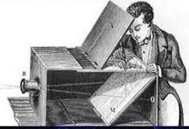

**Johann Zahn with Camera Obscura**

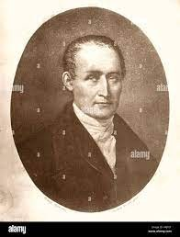

**Johann Zahn**

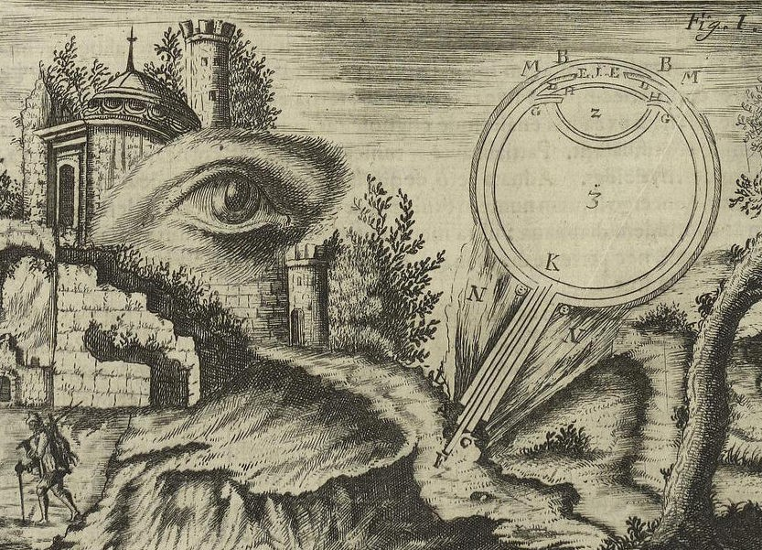

**Johann Zahn’s OculusArtificialis(1685)**

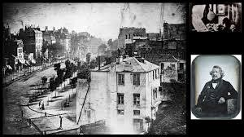

**Louis Daguerre and the First Image he Captured using Daguerreotype**

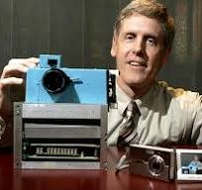

**Steve Sasson**

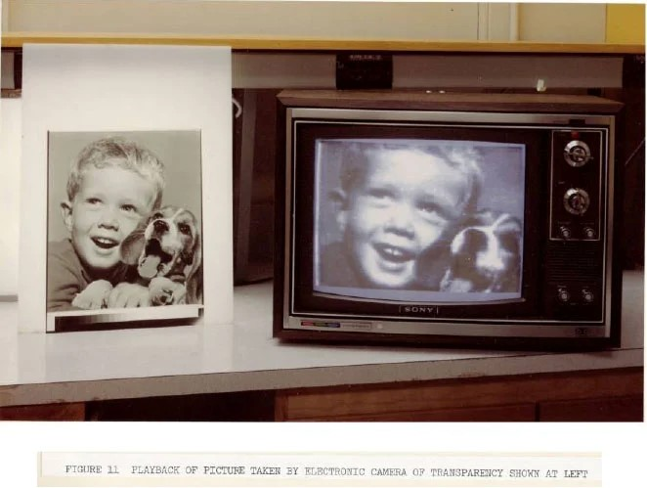

**Playback of Picture taken by Electronic Camera of Transparency shown at left**